**-- WITH USE OF INNER JOIN PRINT THE ONLY MATH SUBJECT STUDENT NAME AND MARKS --**

SELECT students.student_name, marks.marks_obtained as math

FROM marks

INNER JOIN students ON marks.student_id = students.student_id

INNER JOIN subject ON marks.subject_id = subject.subject_id

WHERE subject.subject_name = 'Math'

ORDER BY students.student_id;

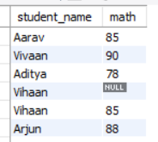

**-- WITH USE OF INNER JOIN PRINT THE ONLY ENGLISH SUBJECT STUDENT NAME AND MARKS --**

SELECT students.student_name, marks.marks_obtained as english

FROM marks

INNER JOIN students ON marks.student_id = students.student_id

INNER JOIN subject ON marks.subject_id = subject.subject_id

WHERE subject.subject_name = 'English'

ORDER BY students.student_id;

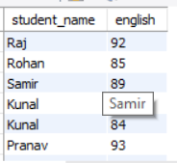

**-- ALL STUDENT RESULT –**

SELECT

students.student_name,

subject.subject_name,

marks.marks_obtained,

marks.grade,

result.total_marks_obtained,

result.result_status

FROM students

INNER JOIN marks ON students.student_id = marks.student_id

INNER JOIN subject ON marks.subject_id = subject.subject_id

INNER JOIN result ON students.student_id = result.student_id

ORDER BY

students.student_id,

subject.subject_name;

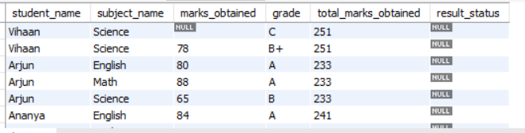

**-- 1 student all marks –**

SELECT

students.student_name,

subject.subject_name,

marks.marks_obtained,

marks.grade,

result.total_marks_obtained,

result.result_status

FROM

students

INNER JOIN marks ON students.student_id = marks.student_id

INNER JOIN subject ON marks.subject_id = subject.subject_id

INNER JOIN result ON students.student_id = result.student_id

WHERE

students.student_id = 1

ORDER BY

subject.subject_name;

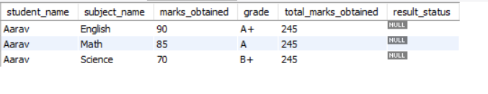

**-- HIGHEST MARKS of math subject –**

SELECT

students.student_name,

marks.marks_obtained AS highest_marks_of_math

FROM

marks

INNER JOIN subject ON marks.subject_id = subject.subject_id

INNER JOIN students ON marks.student_id = students.student_id

WHERE

subject.subject_name = 'Math'

ORDER BY

marks.marks_obtained DESC

LIMIT 1;



**-- LOWEST MARKS of math subject –**

SELECT

students.student_name,

marks.marks_obtained AS highest_marks_of_math

FROM

marks

INNER JOIN subject ON marks.subject_id = subject.subject_id

INNER JOIN students ON marks.student_id = students.student_id

WHERE

subject.subject_name = 'Math'

AND marks.marks_obtained IS NOT NULL

ORDER BY

marks.marks_obtained ASC

LIMIT 1;

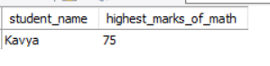

**-- SUBJECT detail –**

SELECT

subject.subject_name

FROM

subject;



**-- exams detail –**

SELECT * FROM exam;

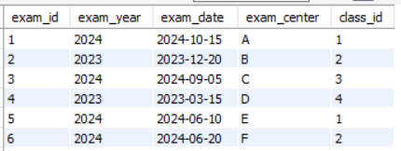

**-- Gender of students—**

SELECT

students.student_name,

gender.gender_name

FROM

students

INNER JOIN gender ON students.gender_id = gender.gender_id;



**-- SCIENCE SUBJEC FINAL RESULT—**

SELECT

students.student_id,

students.student_name,

SUM(CASE WHEN marks.subject_id = 2 THEN marks.marks_obtained ELSE 0 END) AS science,

SUM(CASE WHEN marks.subject_id = 4 THEN marks.marks_obtained ELSE 0 END) AS science_practical,

SUM(CASE WHEN marks.subject_id IN (2, 4) THEN marks.marks_obtained ELSE 0 END) AS total_marks

FROM

students

INNER JOIN

marks ON students.student_id = marks.student_id

WHERE

marks.subject_id IN (2, 4)

GROUP BY

students.student_id, students.student_name;



**-- course code—**

SELECT

subject_name,

subject_code

FROM

subject;

-- grade add—

